

Jonathan Mitchell. 27 years old. He is a lawyer at Ackerman law firm in metro Lansing. Likes to keep himself well groomed, especially at his cases.

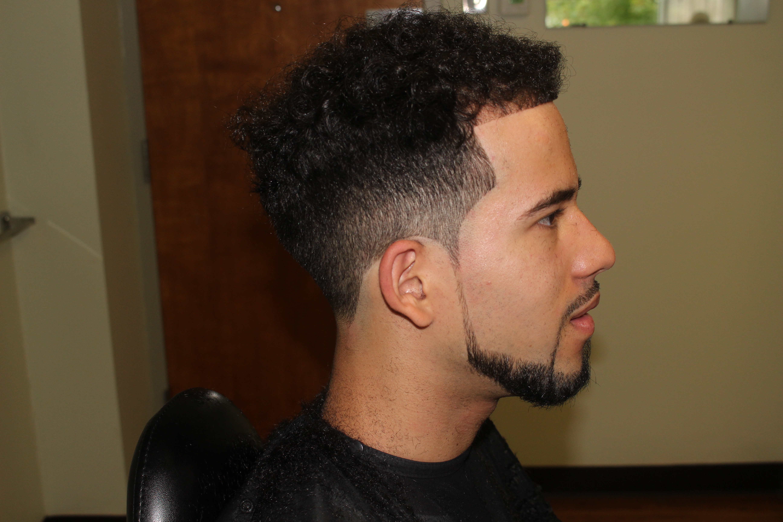

Pablo Montero. 24 Year old graduate student at Michigan State. He is active in his fraternity and likes to look well groomed for every event.



Ali Mheker. 16-year-old student at East Lansing High. Loves to keep a fresh haircut to impress his friends at school.